Econometric Research Association 2nd International Data Analytics and Machine Learning Conference
"The Economics of Data: Foundations for Policy and Regulation"
DATAMACLEA’25
May 5-6, 2025
At the Dinner with Our Keynote Speaker Matthias Finger Before the Start of the Conference

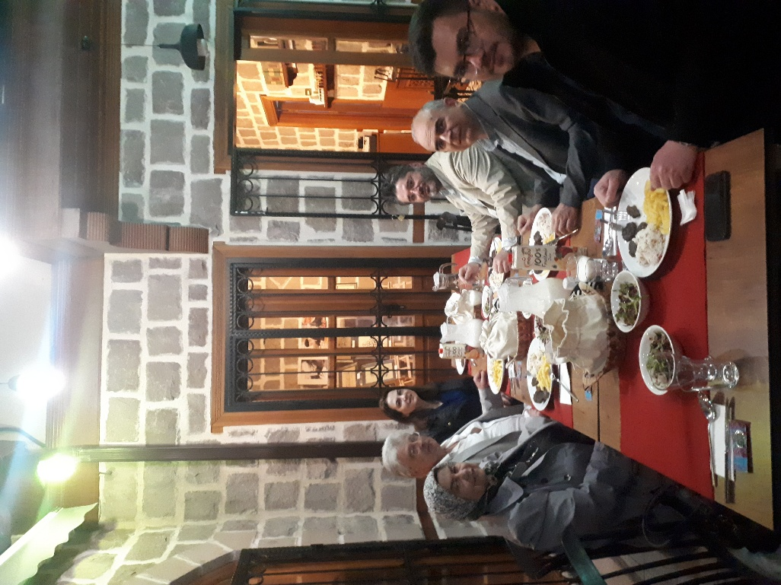

During the Registration

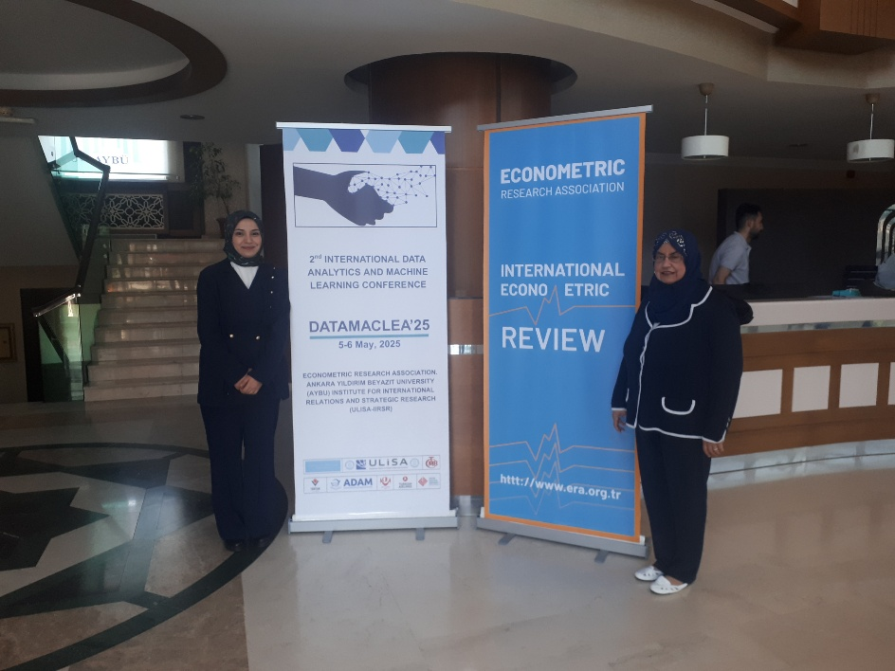

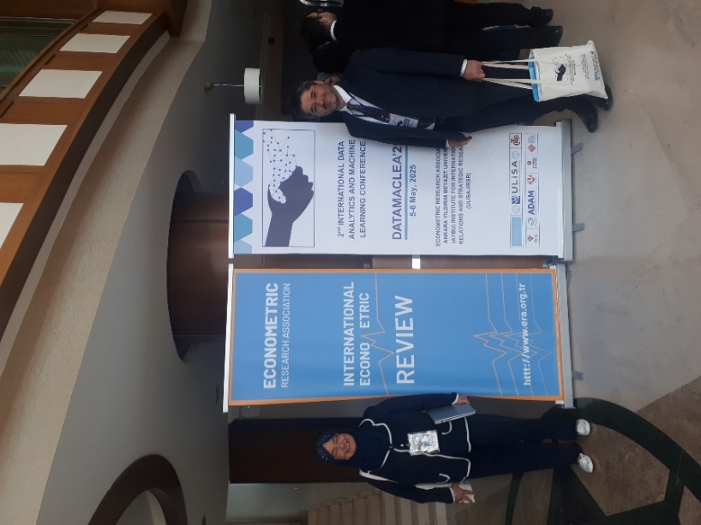

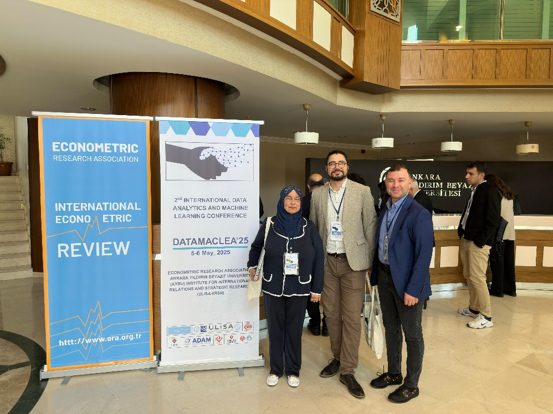

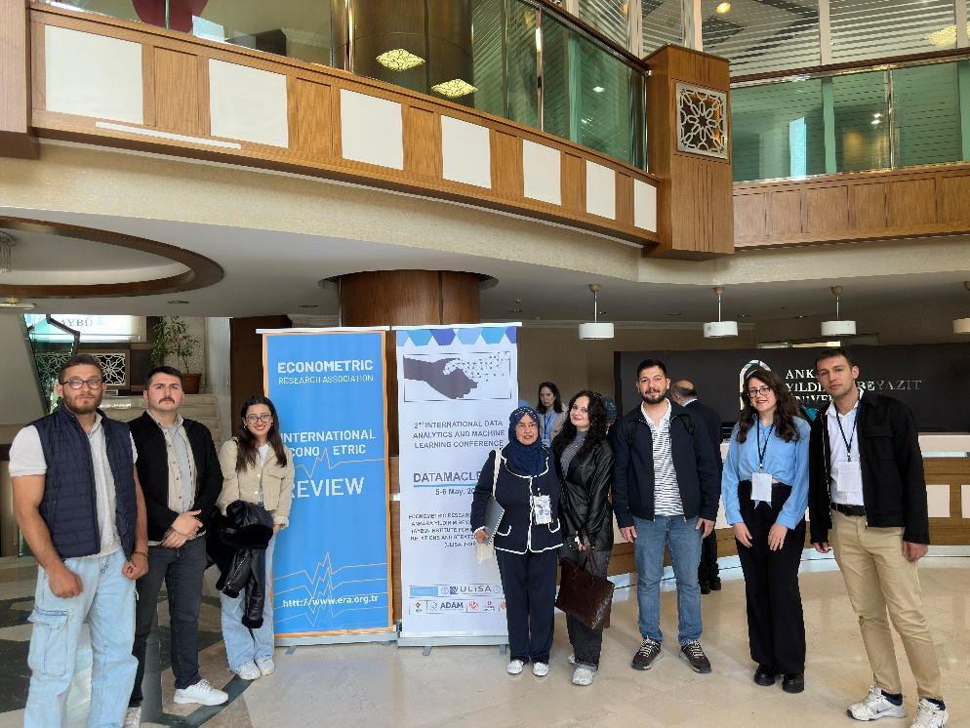

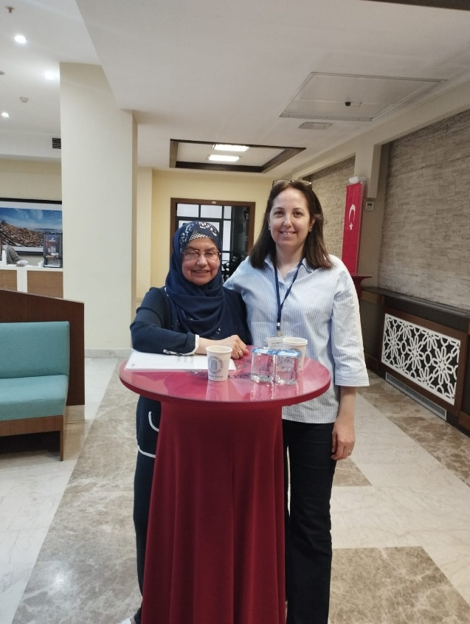

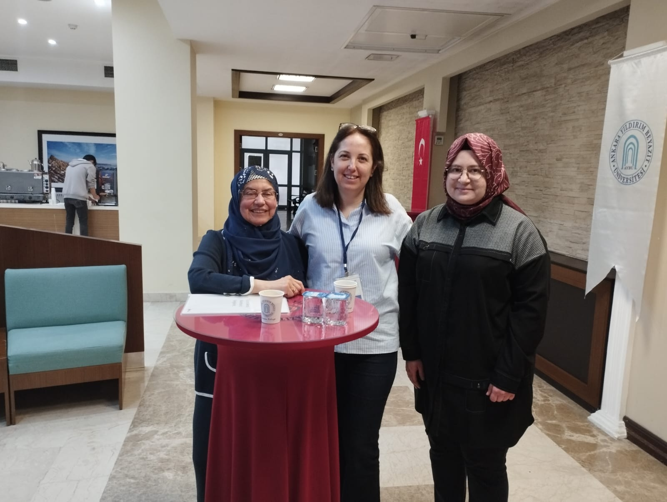

Opening Speeches

Assoc. Prof. Dr. Sıdıka BAŞÇI at AYBU, Department of Economics and Founder and Manager of ERA
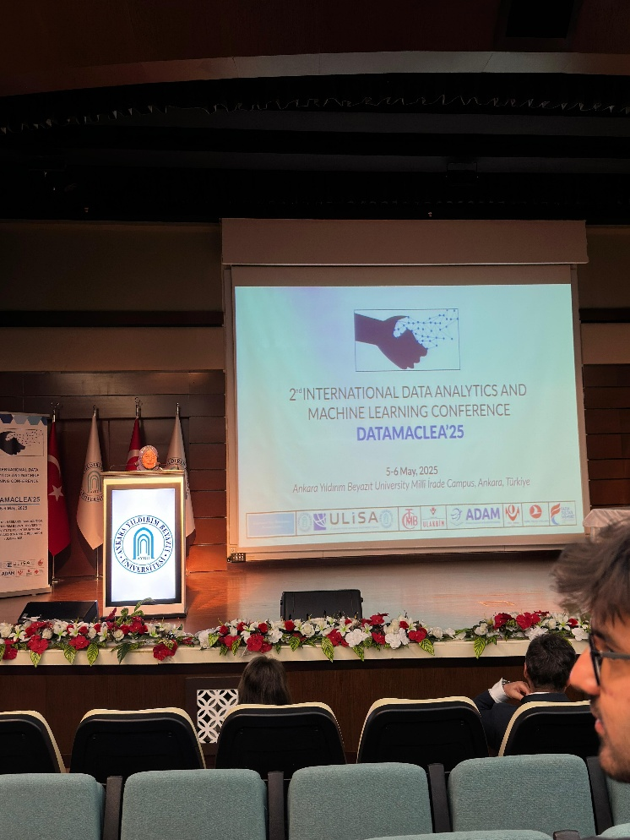

Prof. Dr. İbrahim DEMIR at AYBU, Department of Economics and Manager of ULİSA

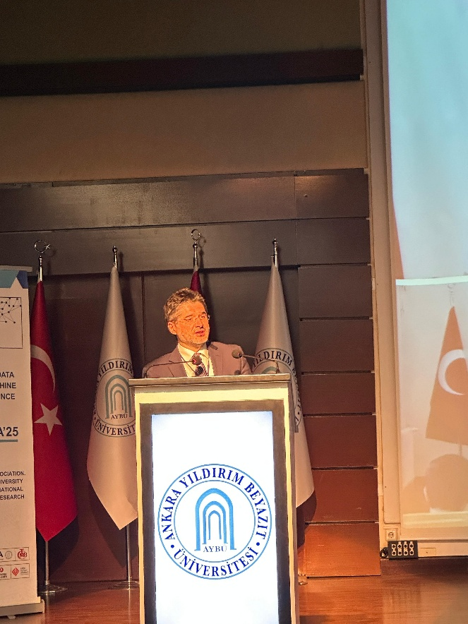

Prof. Dr. Ali Cengiz KÖSEOĞLU, President of AYBU

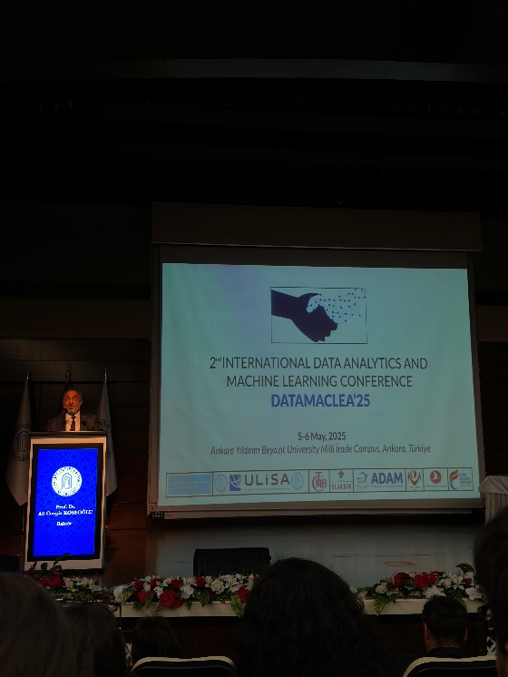
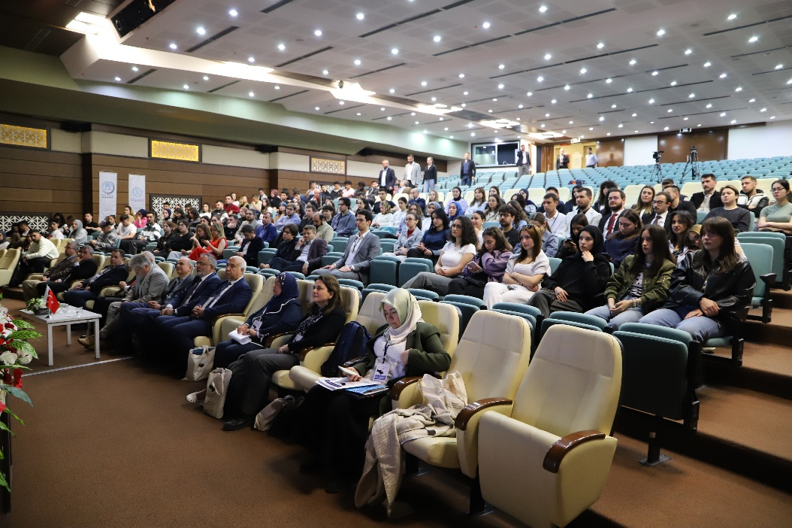

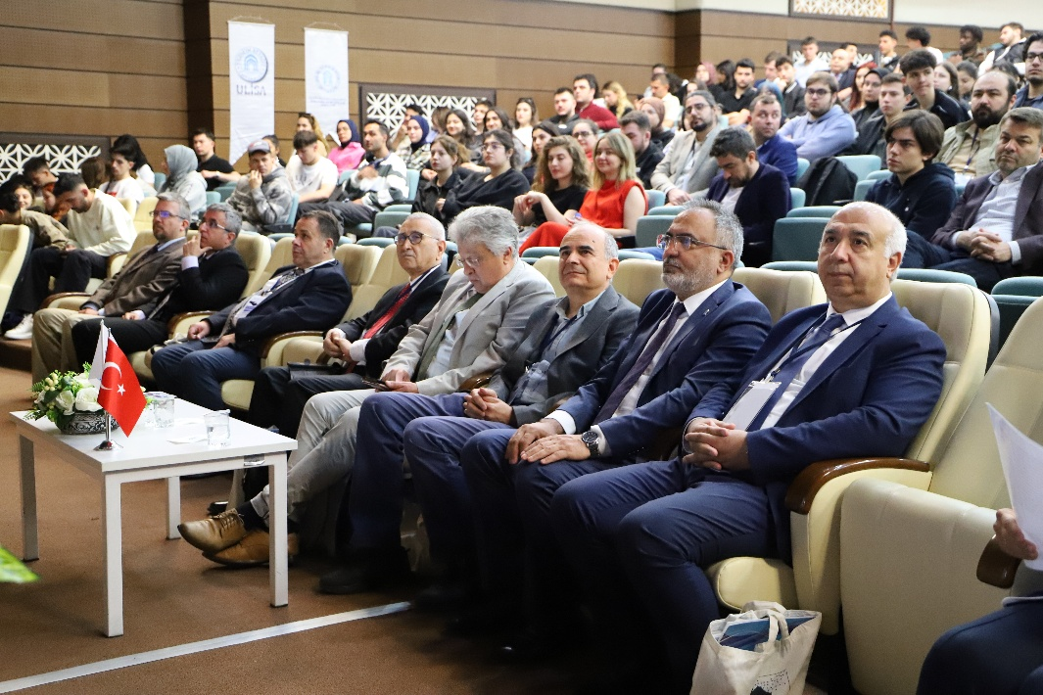

Family Photo

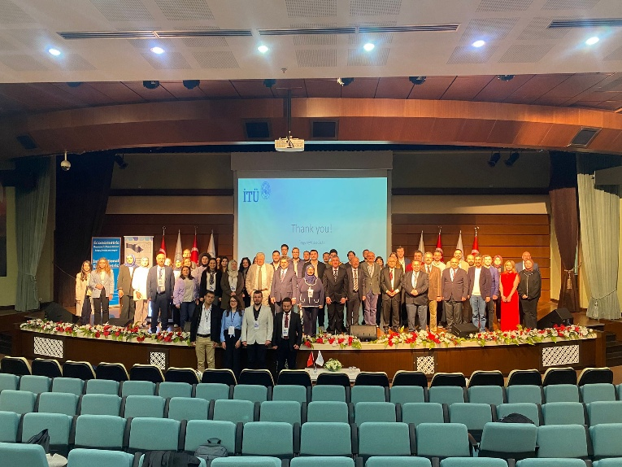

Keynote Speaker (Face to Face) - Prof. Dr. Matthias FINGER, Emeritus Professor Ecole Polytechnique Fédérale Lausanne, Professor at İstanbul Technical University, Türkiye and Part-time Professor, European University Institute
Chair: Assoc. Prof. Dr. Sıdıka BAŞÇI
“Regulating Data and Data Spaces”

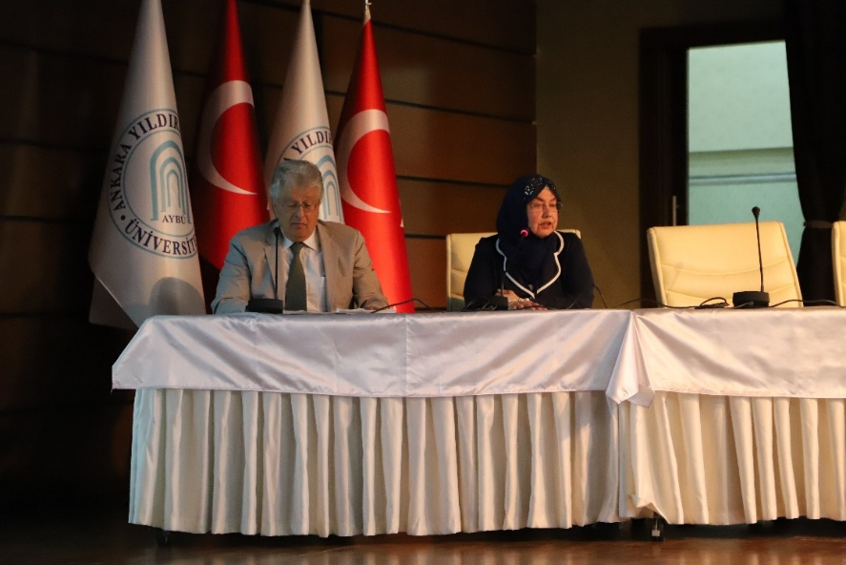

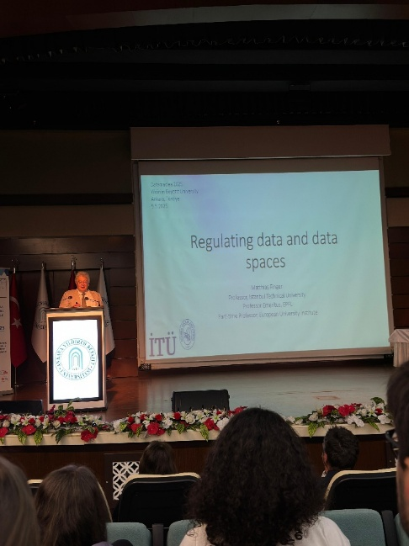

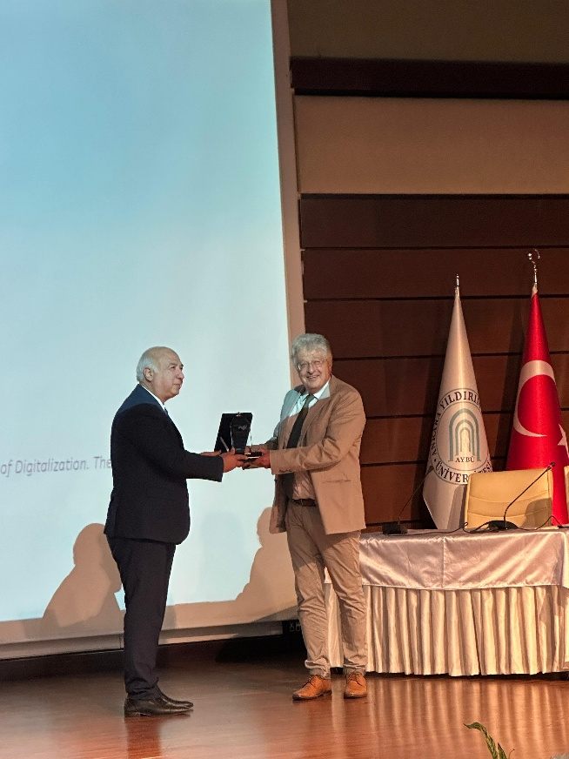

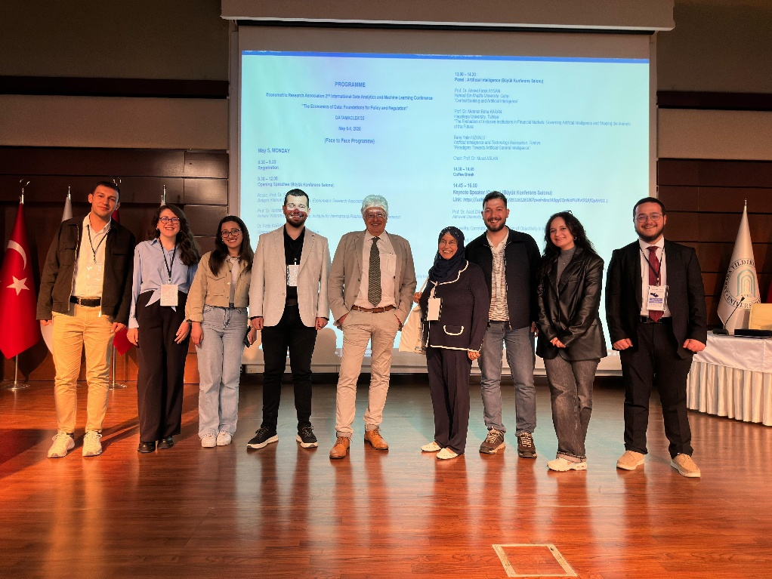

Keynote Speaker (Online): Prof. Dr. Asad Zaman, Akhuwat University, Pakistan and Editor of International Econometric Review
Chair: Prof. Dr. İbrahim DEMİR
“Causality, Correlation, and the Illusion of Objectivity in Machine Learning”

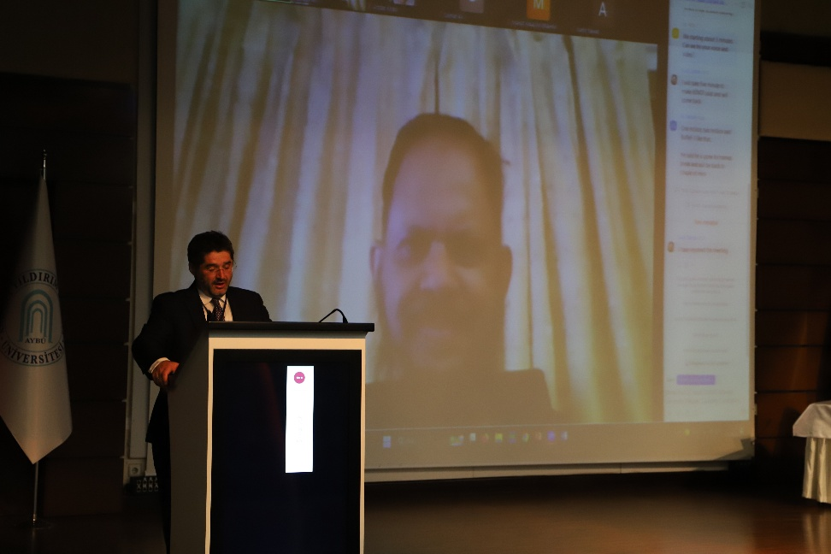

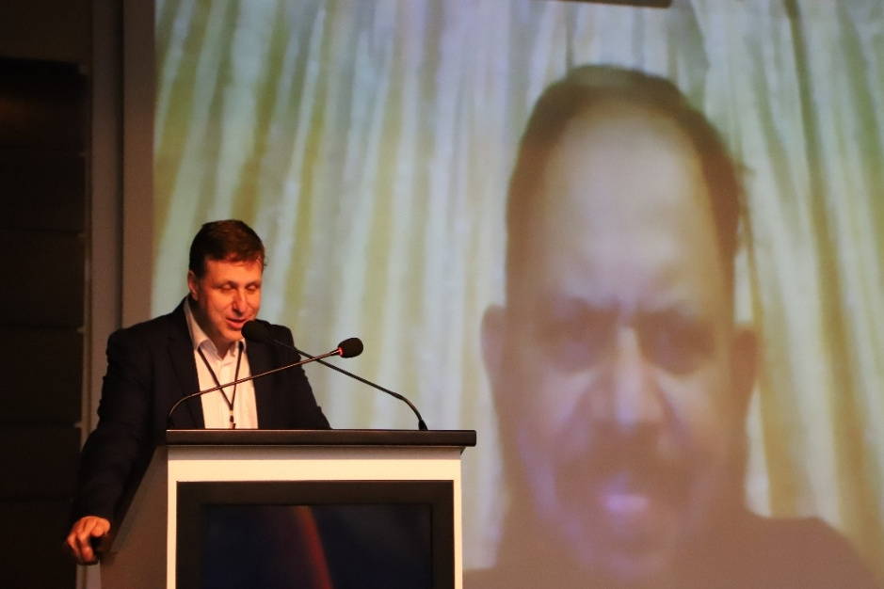

Panel : Artificial Intelligence (Büyük Konferans Salonu)
Prof. Dr. Ahmet Faruk AYSAN
Hamad Bin Khalifa University, Qatar
“Central Banking and Artificial Intelligence”
Prof. Dr. Mehmet Baha KARAN
Hacettepe University, Türkiye
“The Evaluation of Inclusive Institutions in Financial Markets: Governing Artificial Intelligence and Shaping the Markets of the Future
Barış Yalın UZUNLU
Artificial Intelligence and Technology Association, Türkiye
“Paradigms Towards Artificial General Intelligence”
Chair: Prof. Dr. Murat ASLAN
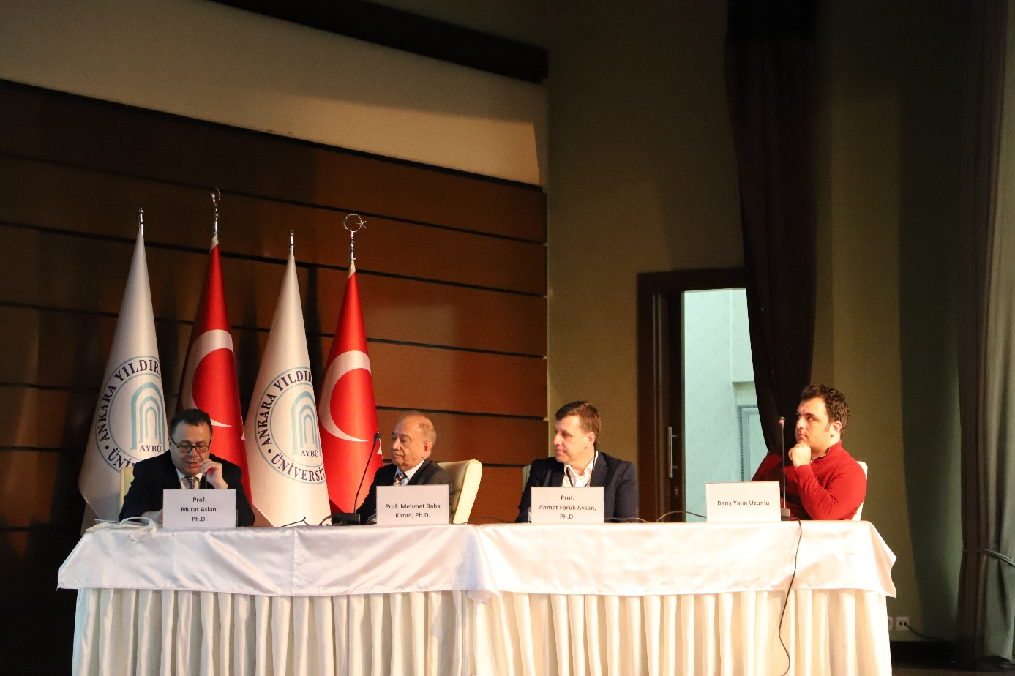
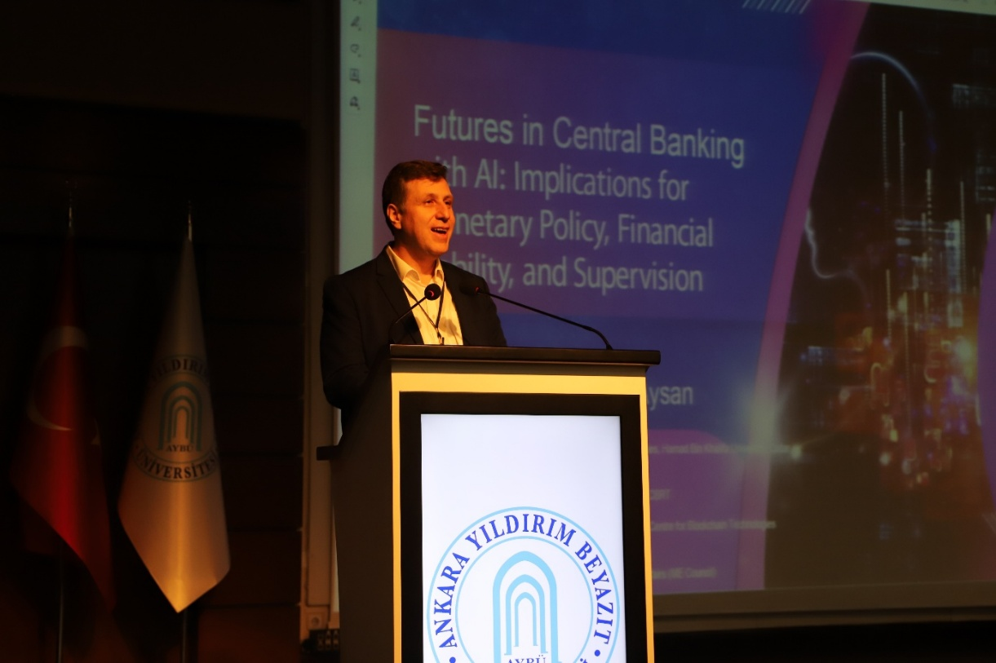
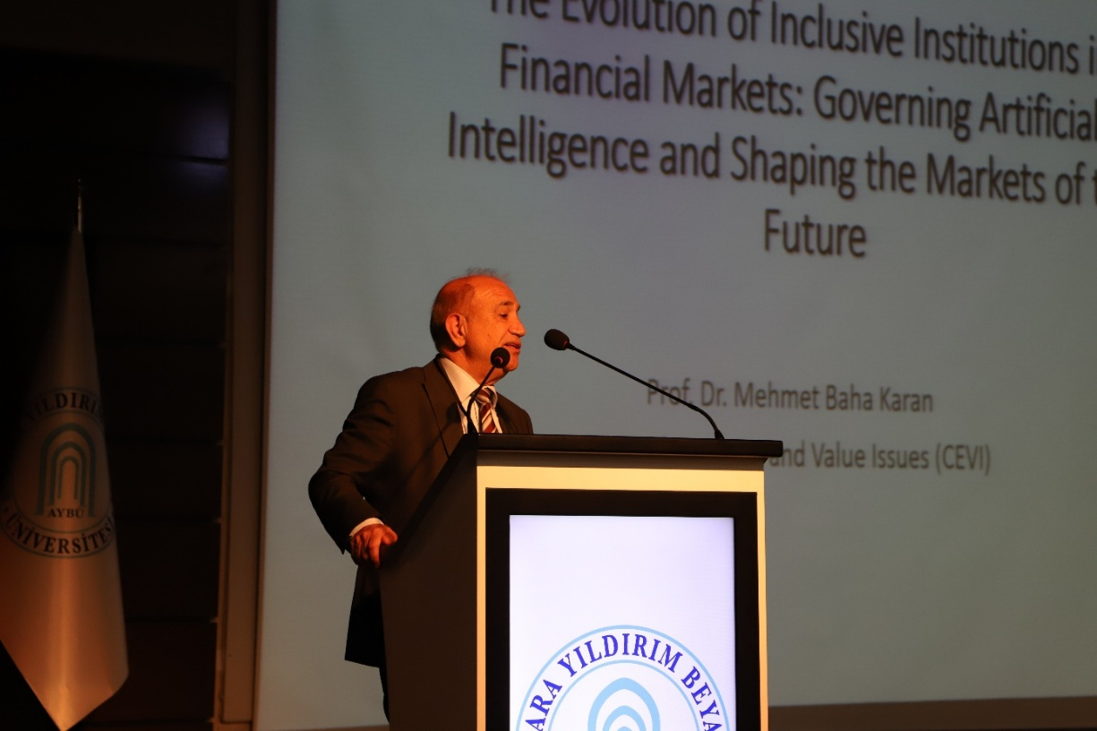
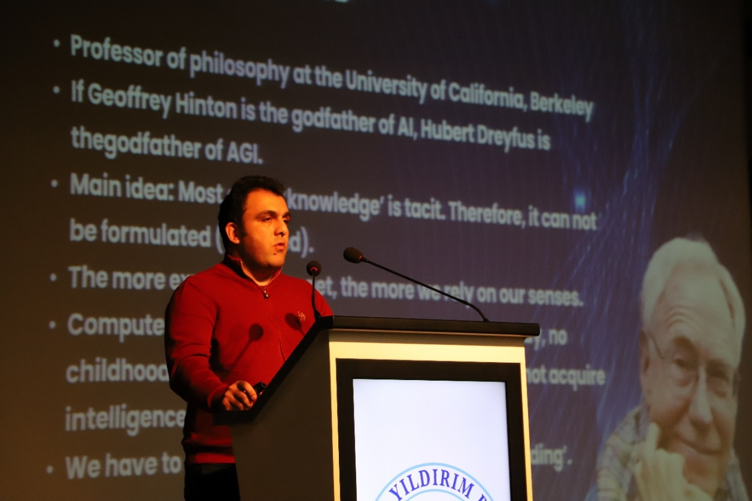
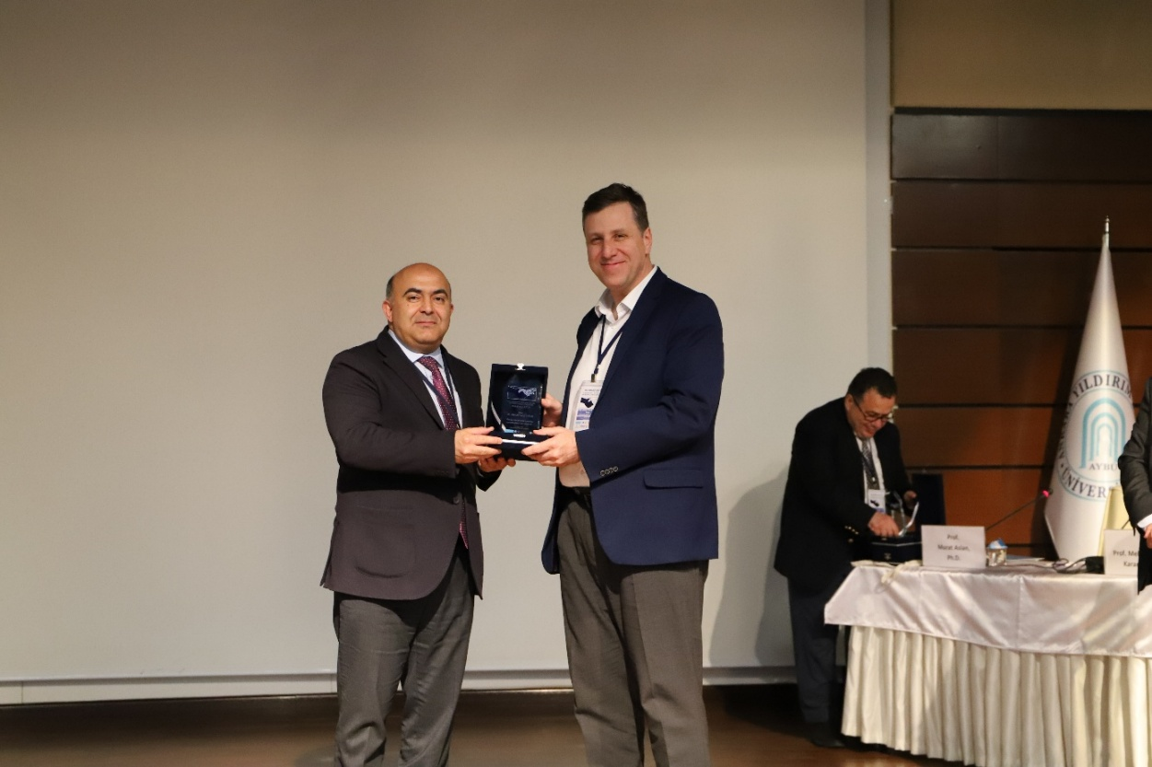
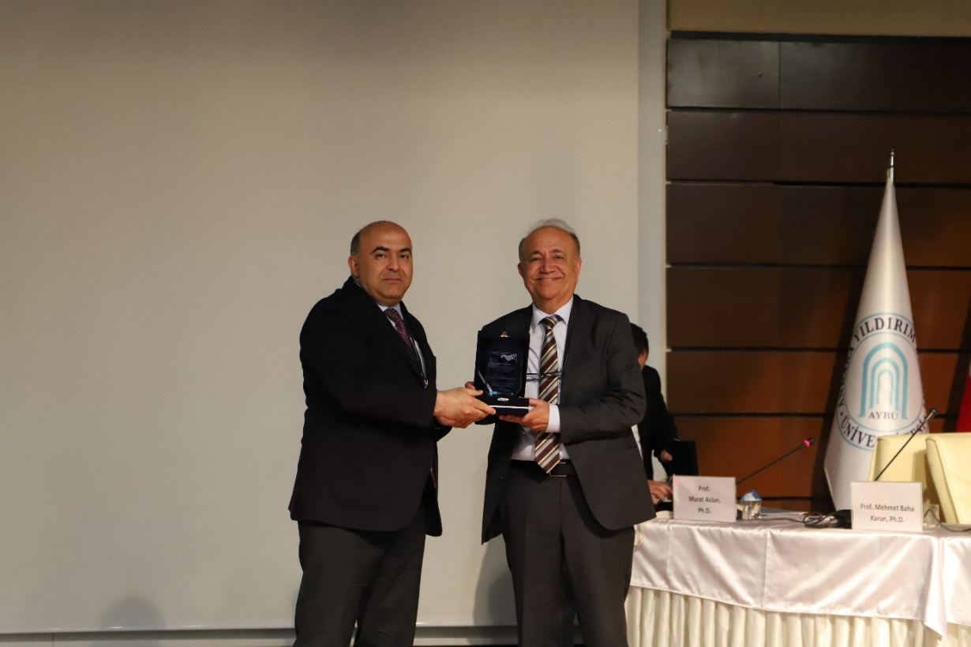

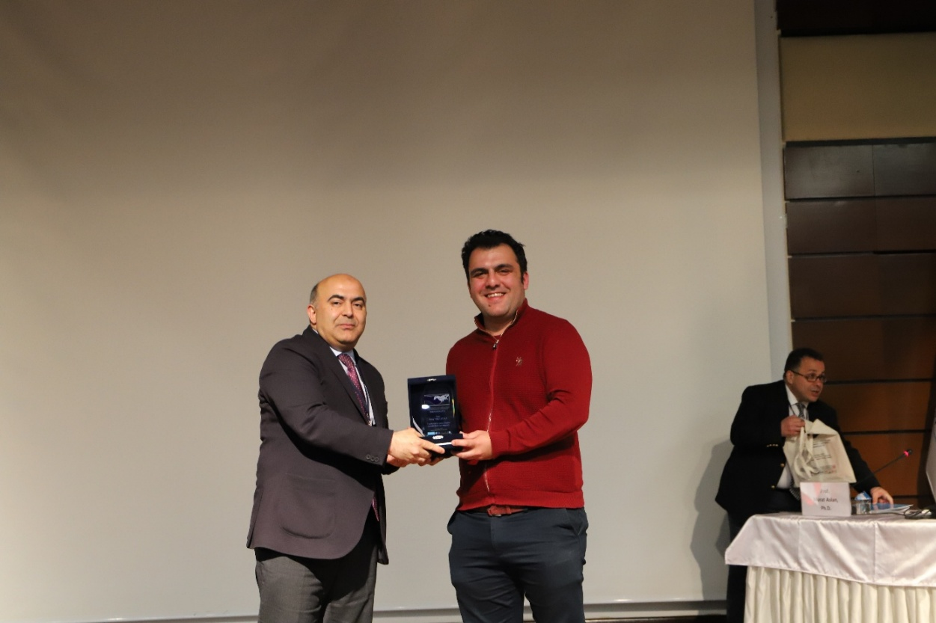

Parallel Sessions
Session 1 – Applied Econometrics and Econometric Theory
Prof. Dr. Selim YILDIRIM
Anadolu University, Türkiye
“Connectedness Among the Sectors Listed in BİST”
Assoc. Prof. Dr. Zeynep UĞUR
Social Sciences University of Ankara, Türkiye
Assist. Prof. Dr. Çağın KARUL
Pamukkale University, Türkiye
“A Fisher-Type Panel Unit Root Test for Bounded Time Series with Cross-Sectional Dependence”
Chair: Prof. Dr. Jülide YILDIRIM
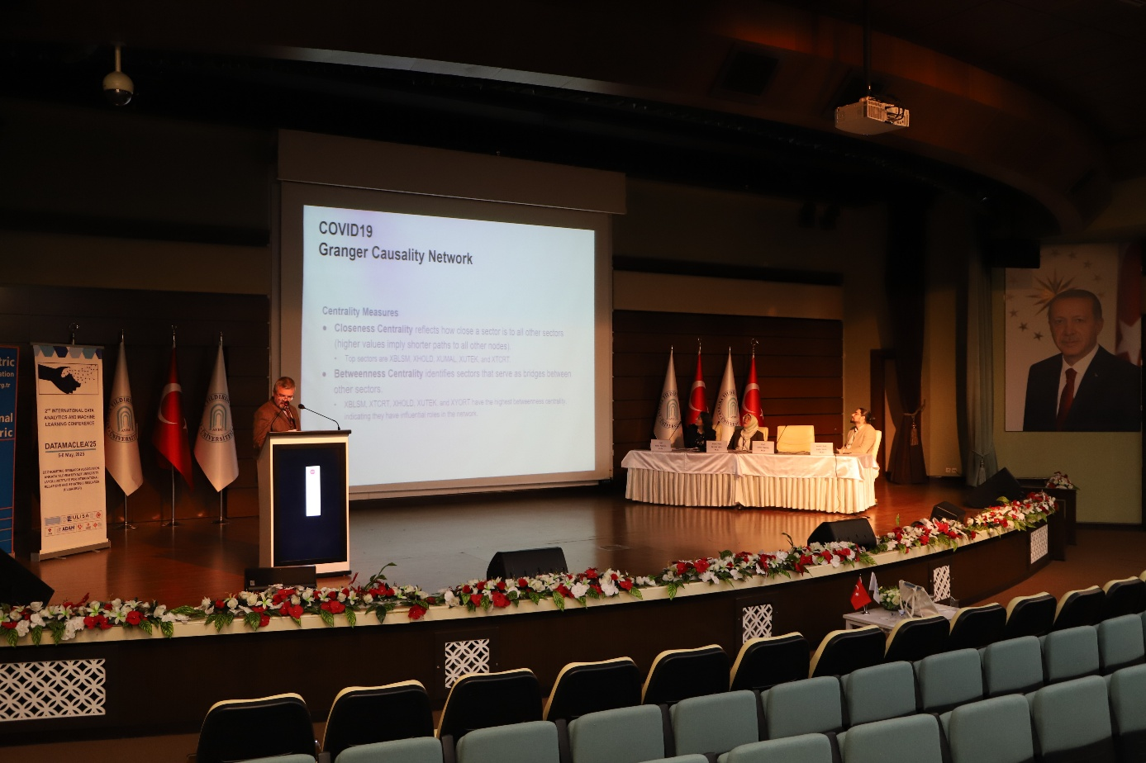

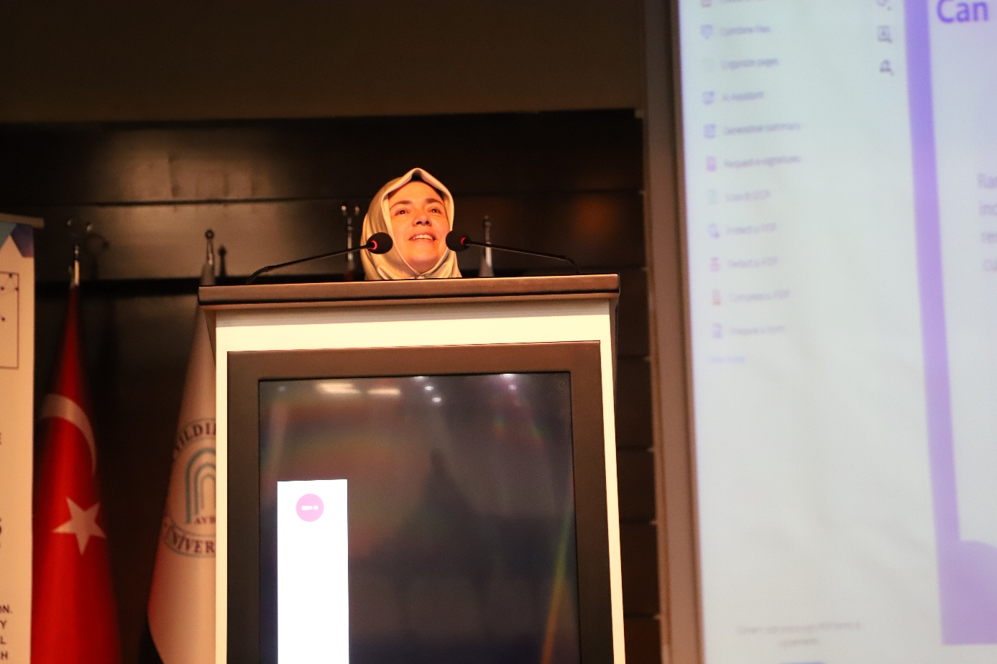
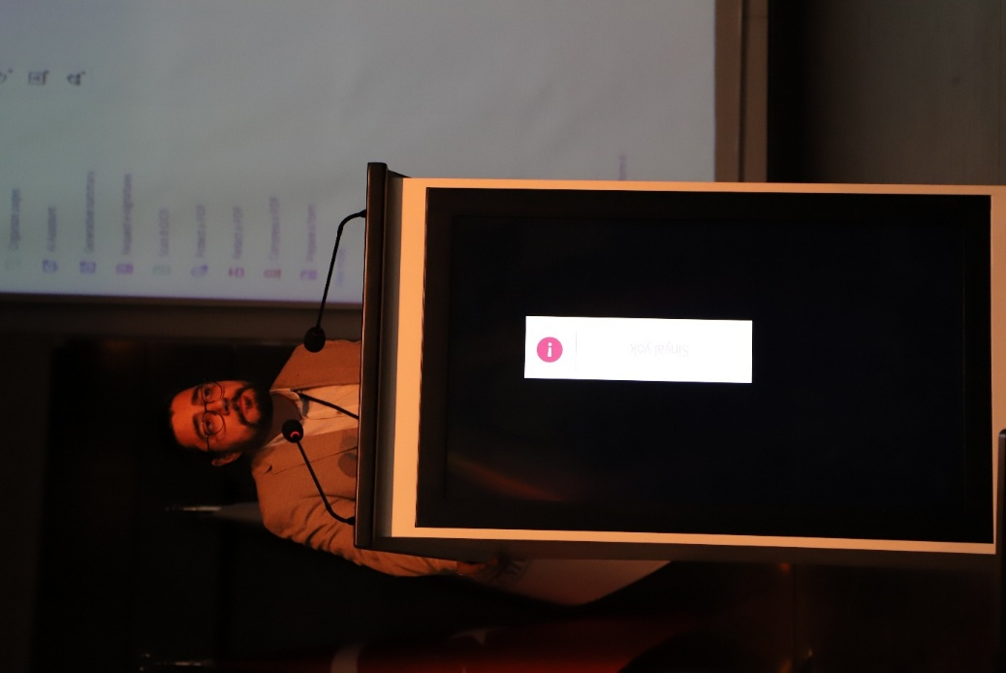

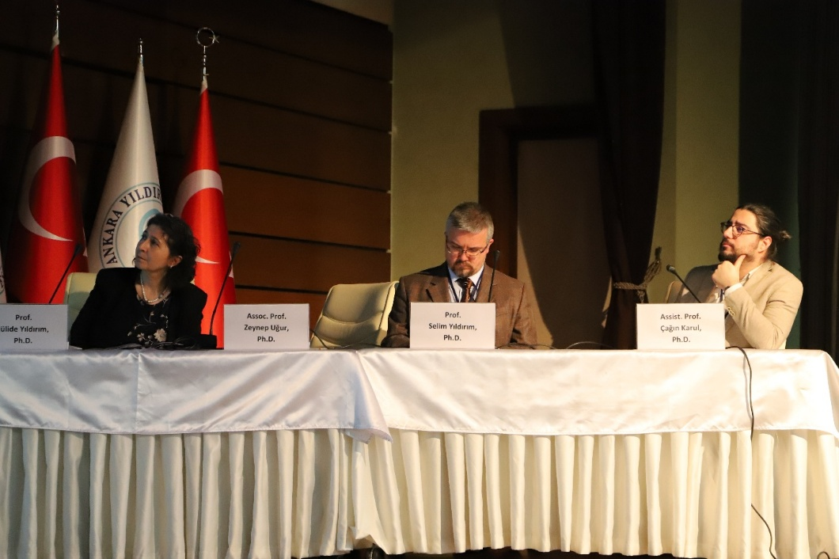
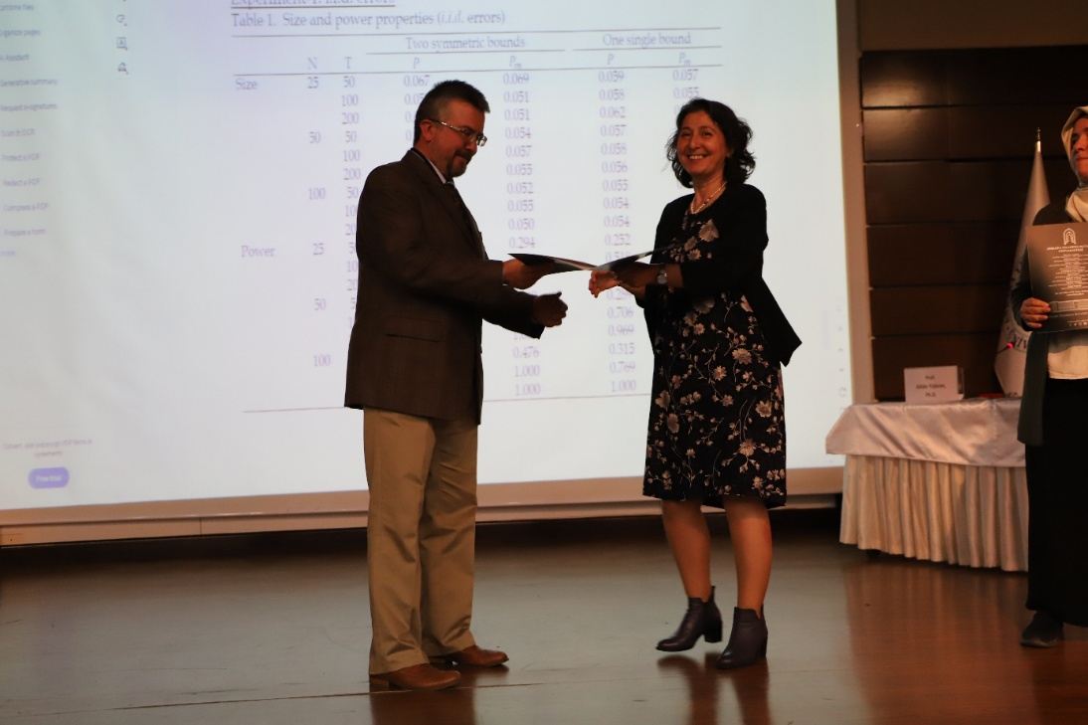

Session 3 – Applied Econometrics
Prof. Dr. Fatih Cemil ÖZBUĞDAY
Ankara Yıldırım Beyazıt University, Türkiye
“Do High Margin Episodes in Turkish Banking Coincide with the Turkish Competition Authority's Investigation Window: Insights from Two- and Three-State Hidden Markov Models”
Assist. Prof. Dr. Şerife Deniz KOLAT
Batman University, Türkiye
“Impact of Distance on Student Preference among Turkish Provinces: A Gravity Model Approach”
Prof. Dr. İbrahim DEMİR
Ankara Yıldırım Beyazıt University, Türkiye
“The Choice for Econometrician, Statistician, Developer, User and Outsourcer of Data Analysis ”
Chair: Prof. Dr. Erdem BAŞÇI

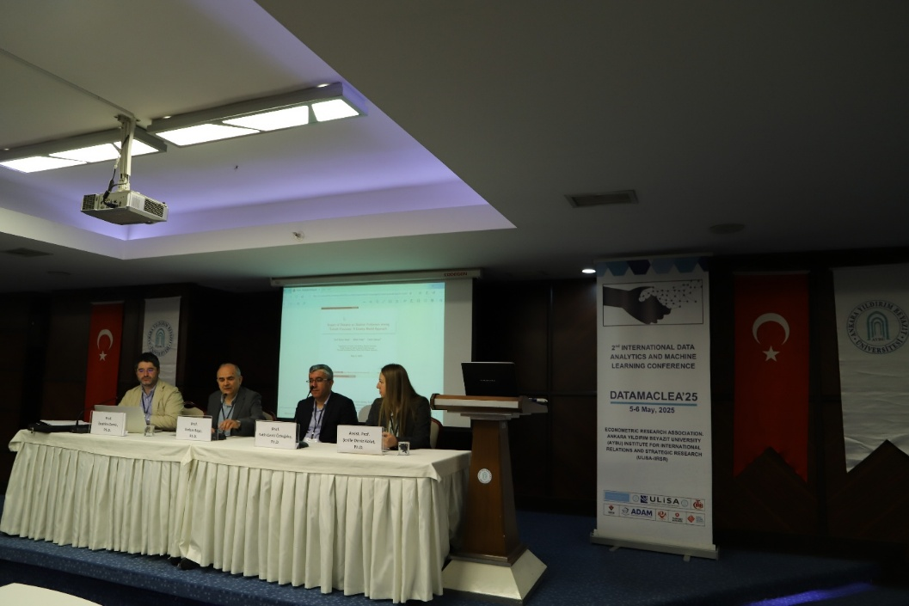

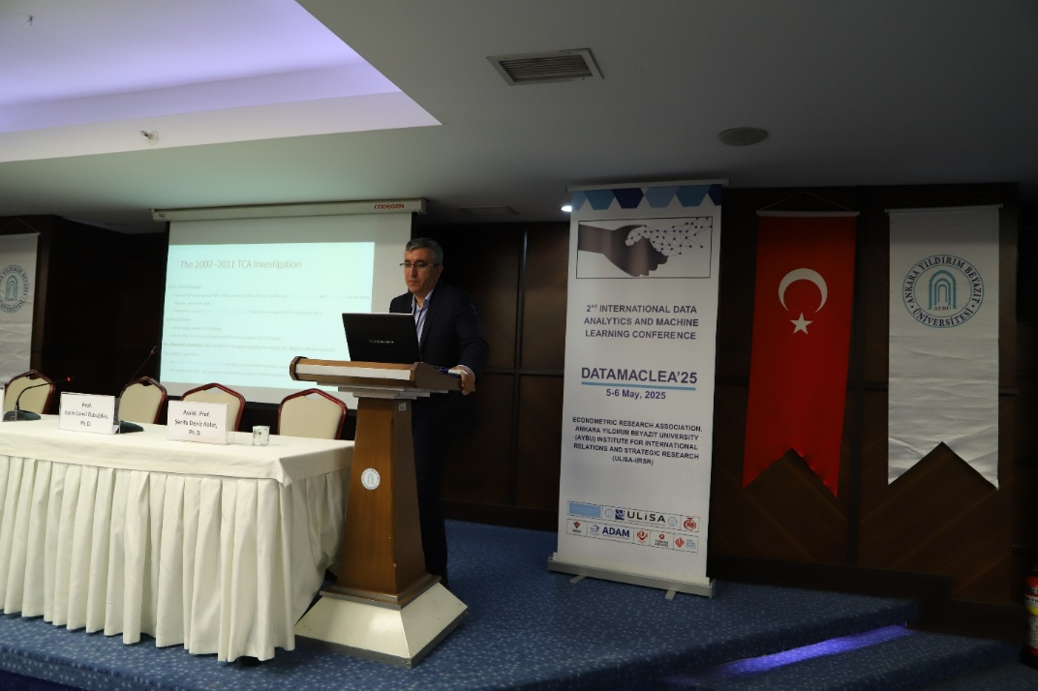
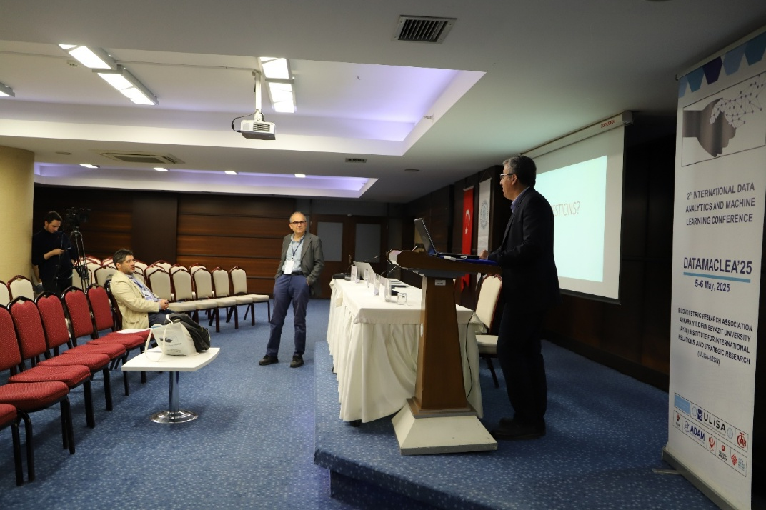

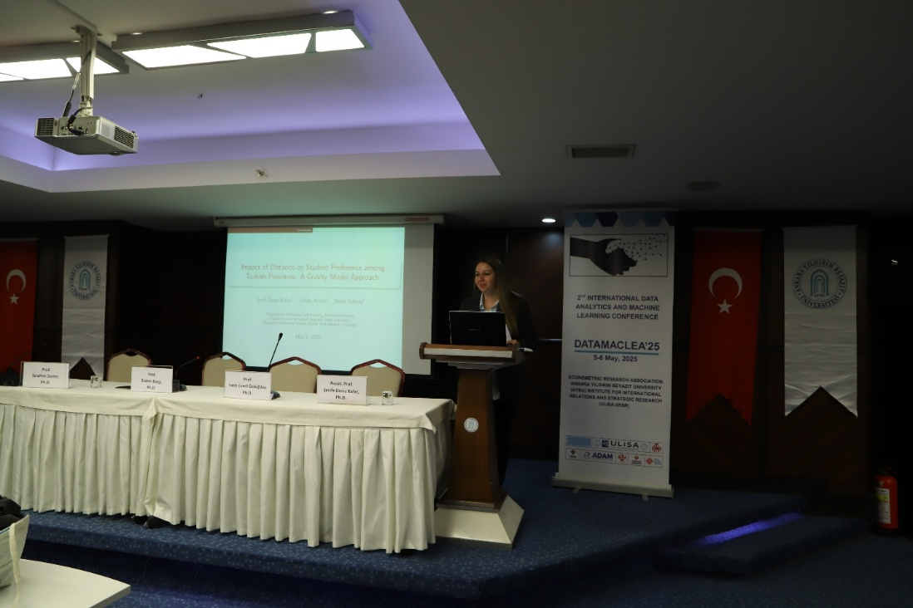
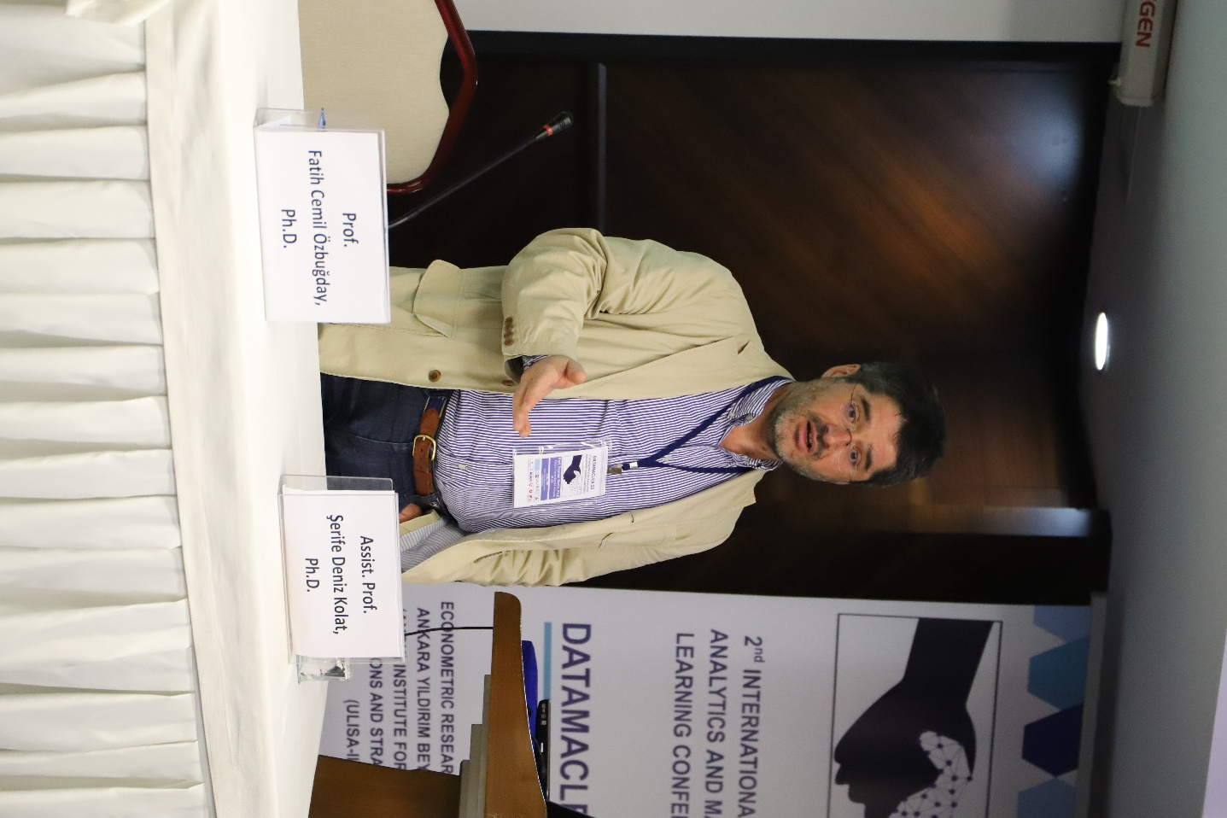

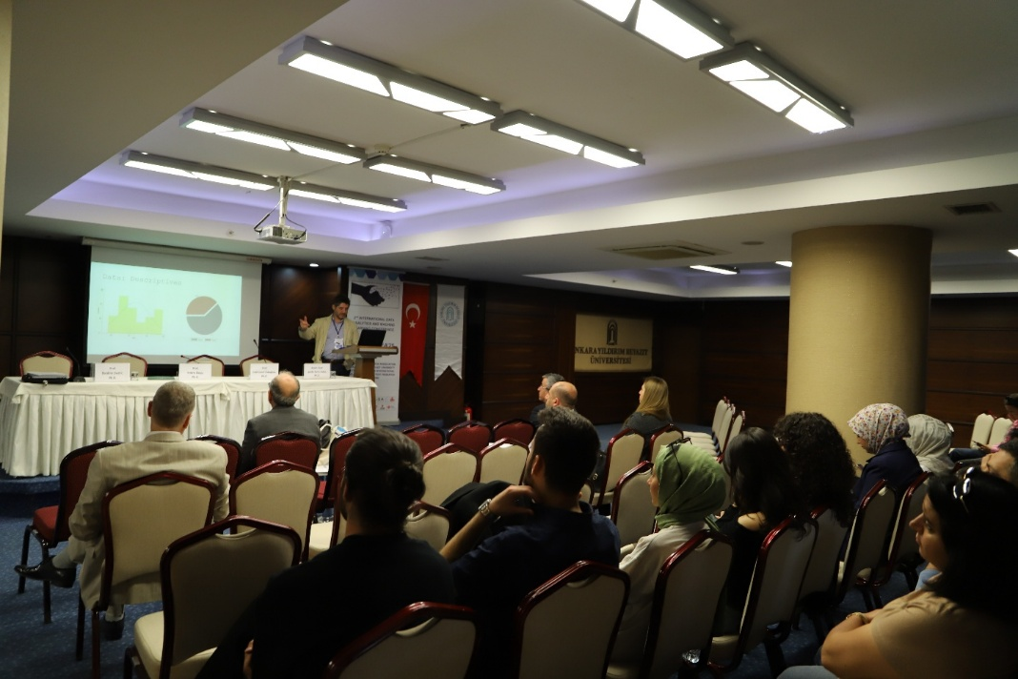
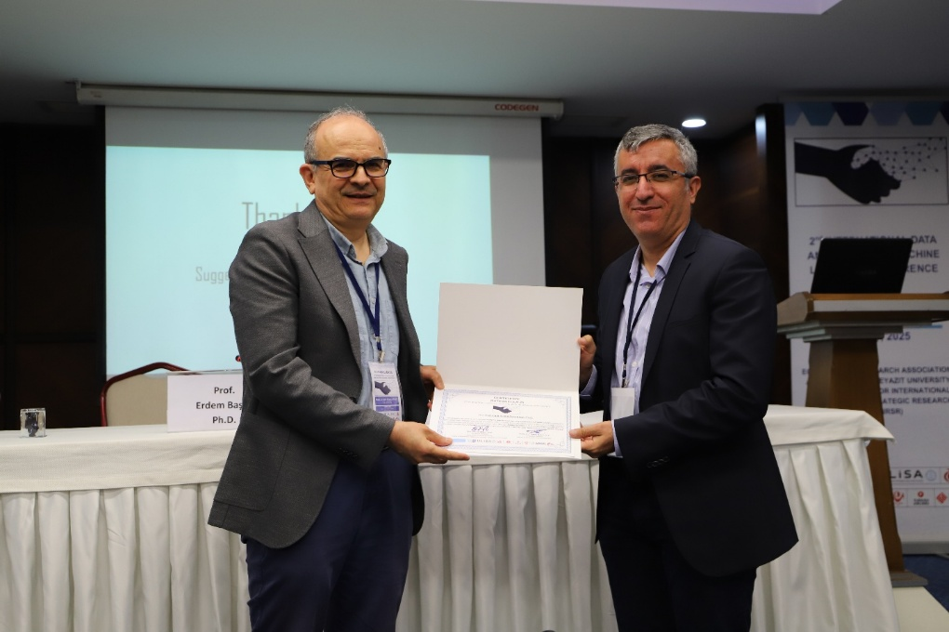

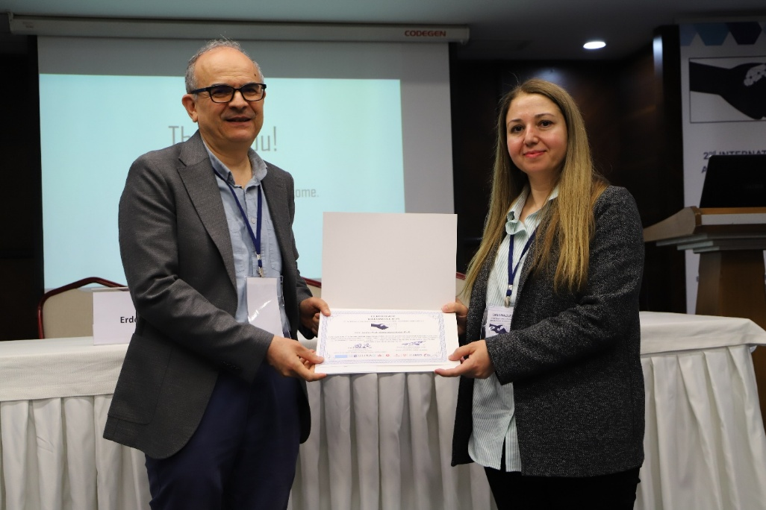

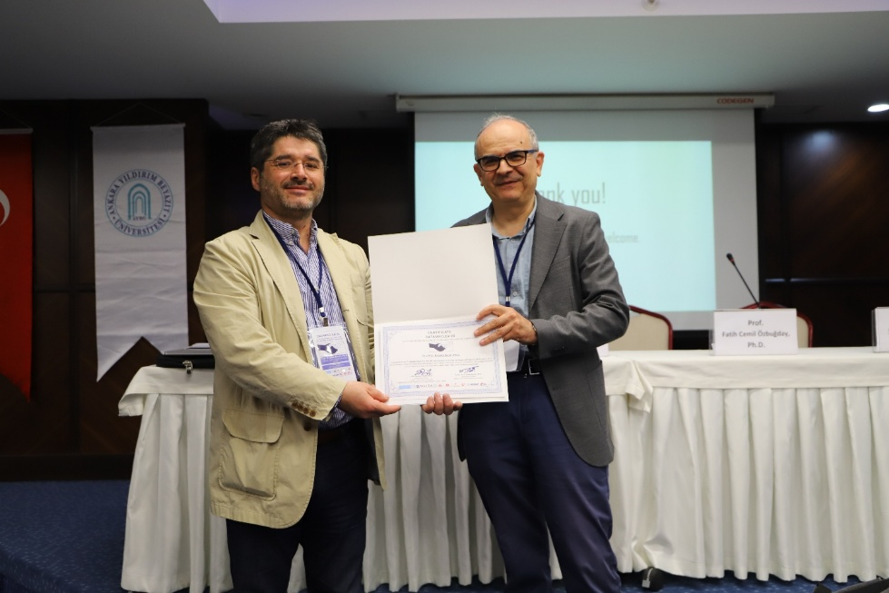

Session 4 – Data Economy and Politics (C202)
MA Student Aybüke MÜNTEMUR
Ankara Yıldırım Beyazıt University,Türkiye
“Demand Deficiency and Inflation in the G20 Countries”
Assist. Prof. Dr. Büşra AĞAN
Ostim Technical University, Türkiye
“Assessing the Moderating Role of Policy Effectiveness for Climate Neutrality: A Quantile-Based Panel Analysis”
Alim SABİR
Graduate School of Social Sciences, Türkiye
“Digital Transformation and Public Innovation in the Turkish World: Examples from Turkey and Azerbaijan”
Prof. Dr. Seyit Mümin CİLASUN
TED University, Türkiye
“Even Announcement Matters? The Effect of CBAM on Turkish Exports and Exporters”
Chair: Assoc. Prof. Dr. Sıdıka BAŞÇI

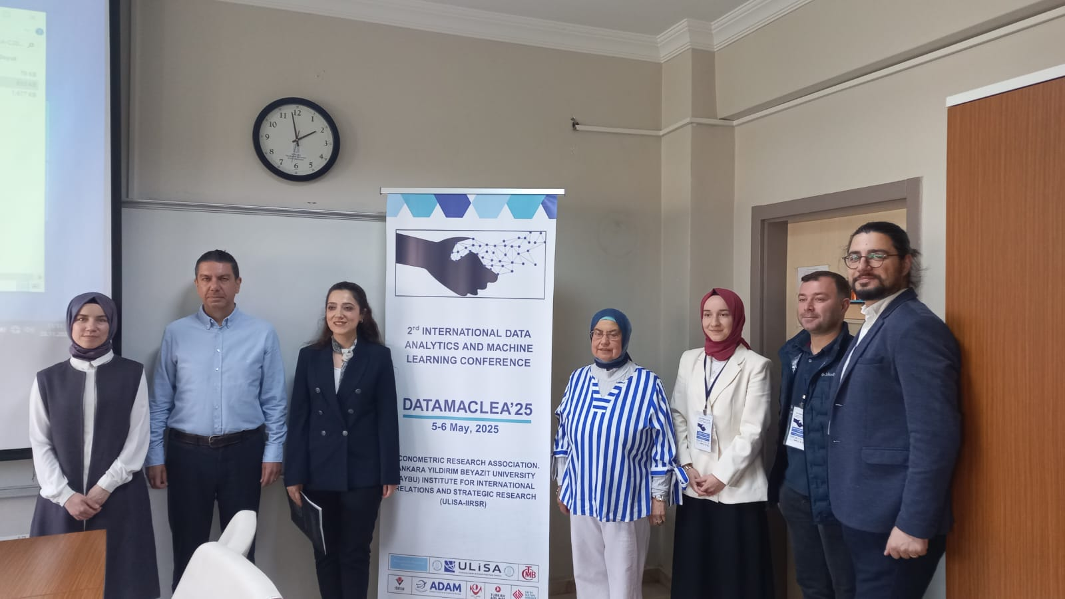

Session 5: Statistical Learning and Inference
Prof. Dr. Erdem BAŞÇI
TED University, Türkiye
“Pricing Behavior in a Dynamic Duopoly”
Assist. Prof. Dr. N. Hande SEVGİ
Ufuk University, Türkiye
“Consistency of the Central Bank of the Republic of Türkiye’s Policy Stance with Its Discourses: A Fuzzy Logic Analysis”
Ph.D. Student, Erdener Emin EKER
TED University, Türkiye
“Impact of Conflict on Concern for Environment”
Chair: Prof. Dr. Muhsin KAR

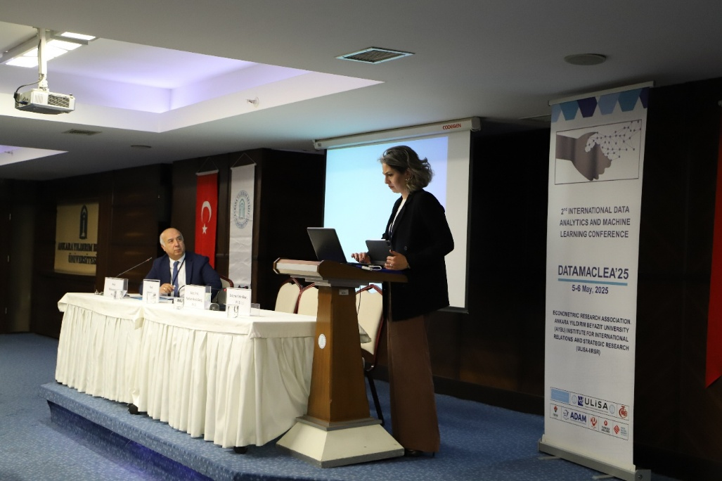

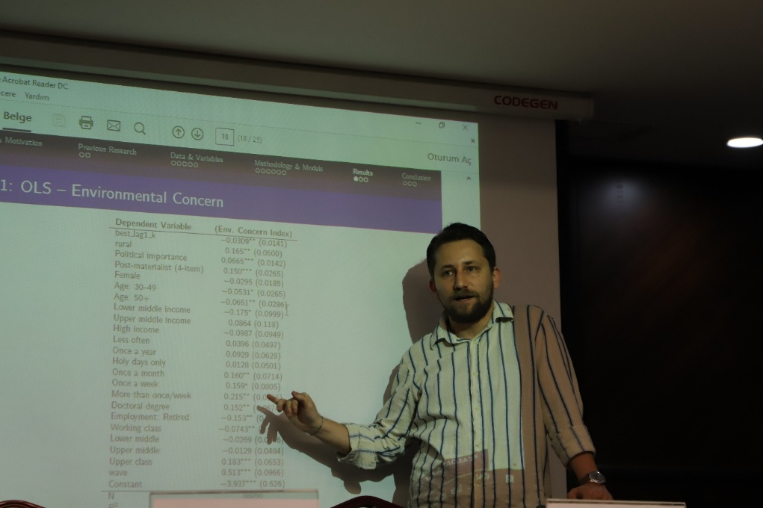
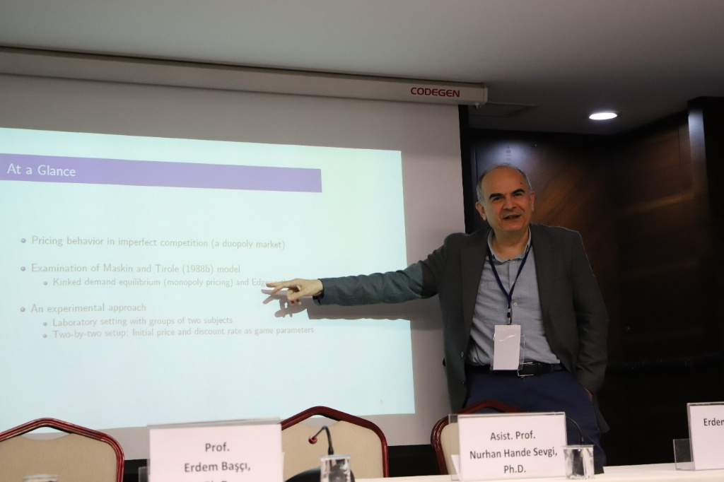

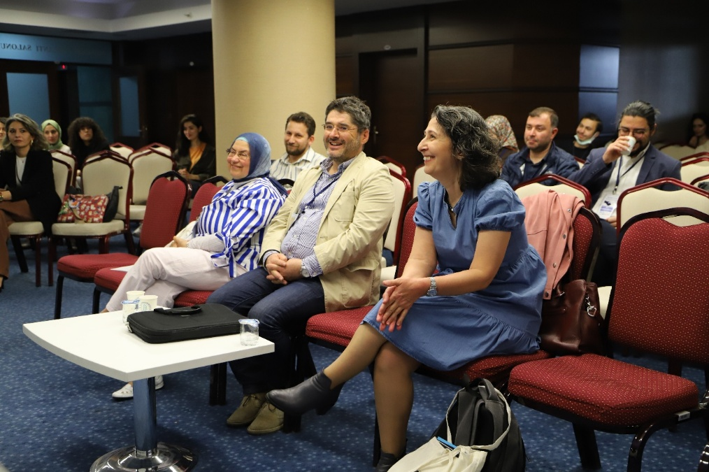
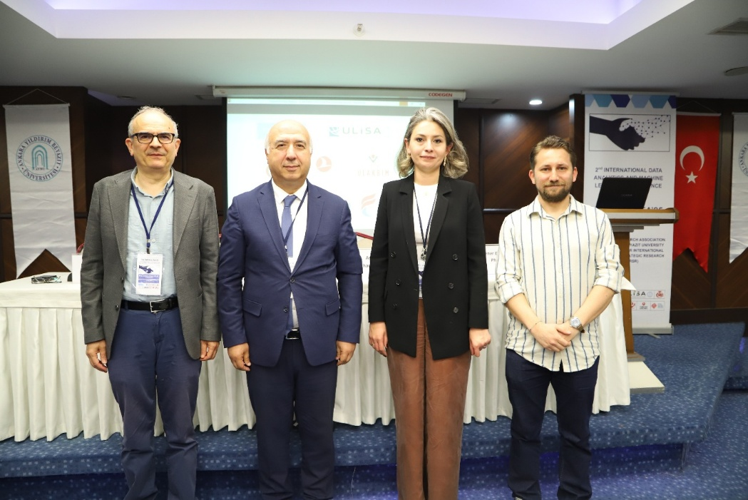

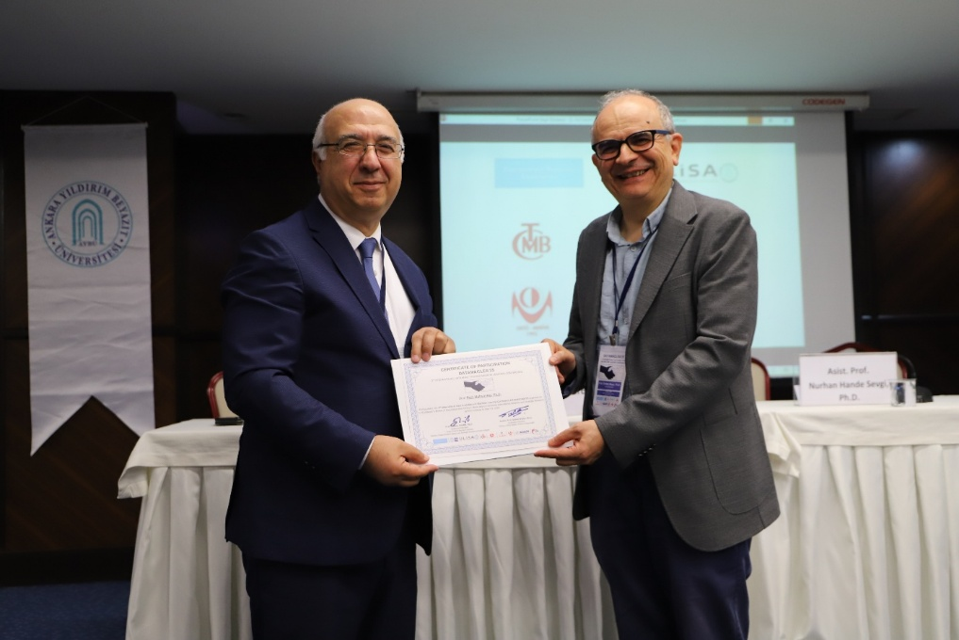

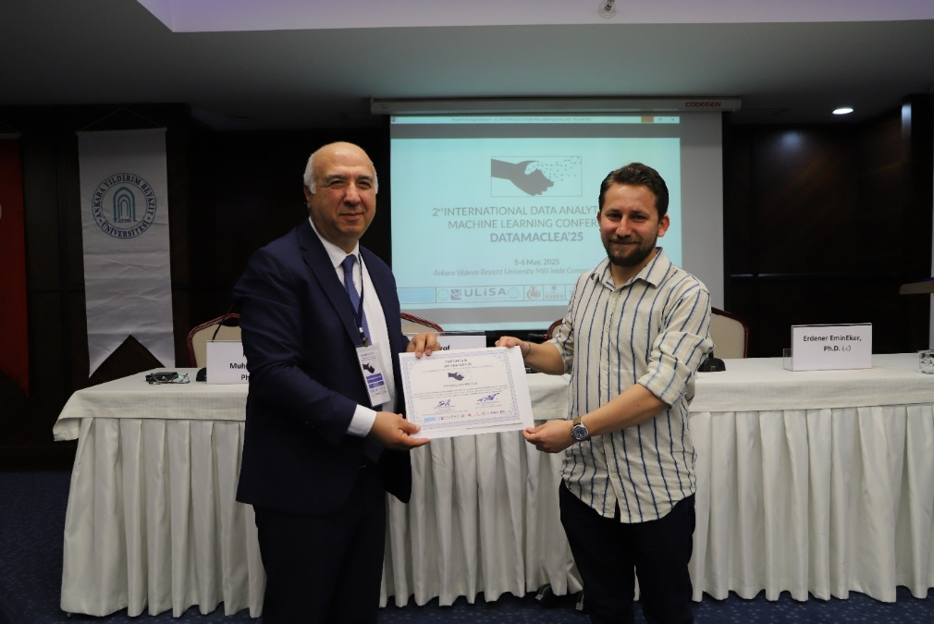

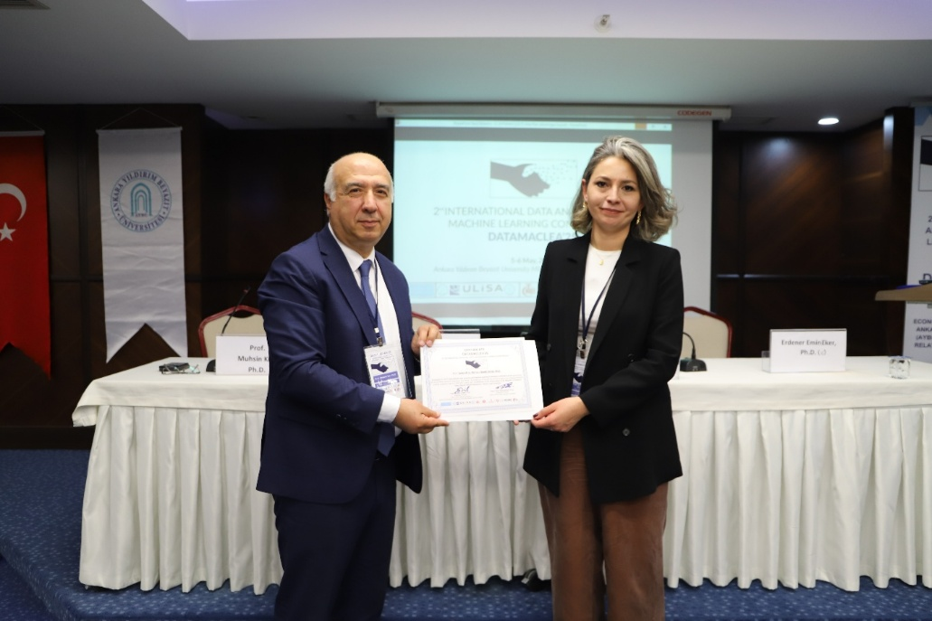

Session 6: Econometrics (Menekşe Salonu)
Ayşenur ŞAHİNLER, Ph.D.
Ankara Yıldırım Beyazıt University, Türkiye
“Determinants of Dollarizations for Türkiye: Evidence from Augmented ARDL Test”
Asist. Prof. Dr. Kağan ÖZDEMİR
İstanbul University, Türkiye
“Non-Linear Cointegration Analysis of Export-Import Coverage Ratio in Turkey between 2013-2024”
Assoc. Prof. Dr. Bahar ERDAL
Ostim Technical University, Türkiye
“The Validity of Fisher Effect in Inflation Targeting Regime in Some European Emerging Economies: Albania, Czech Republic and Romania”
Nurullah GÜLEÇ, Ph.D.
Ankara Yıldırım Beyazıt University, Türkiye
“Exploring the Dynamics Between Inequality and Macroeconomic Variables: A VAR Analysis for Turkey”
Chair: Prof. Dr. Özlem ÖNDER

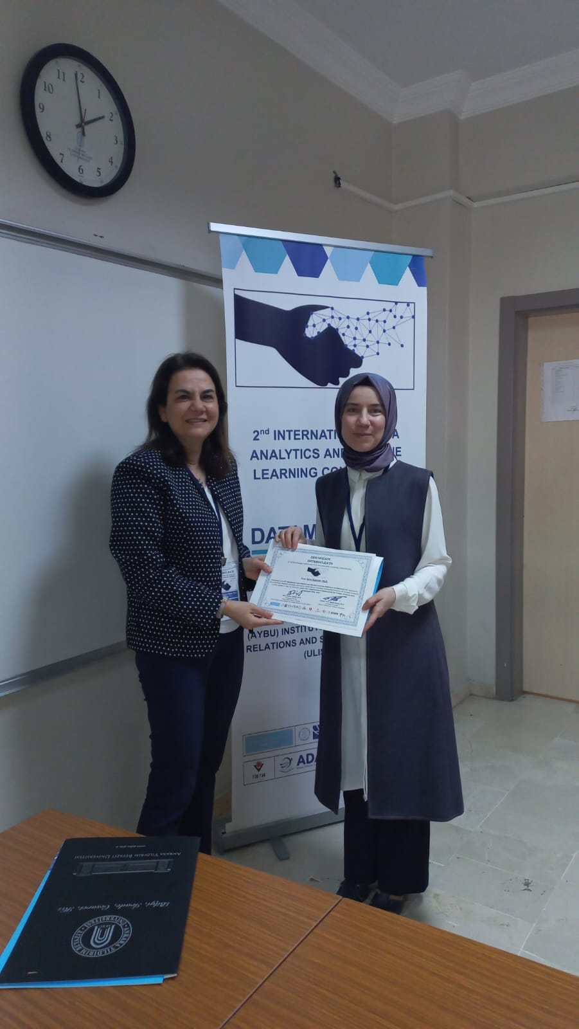
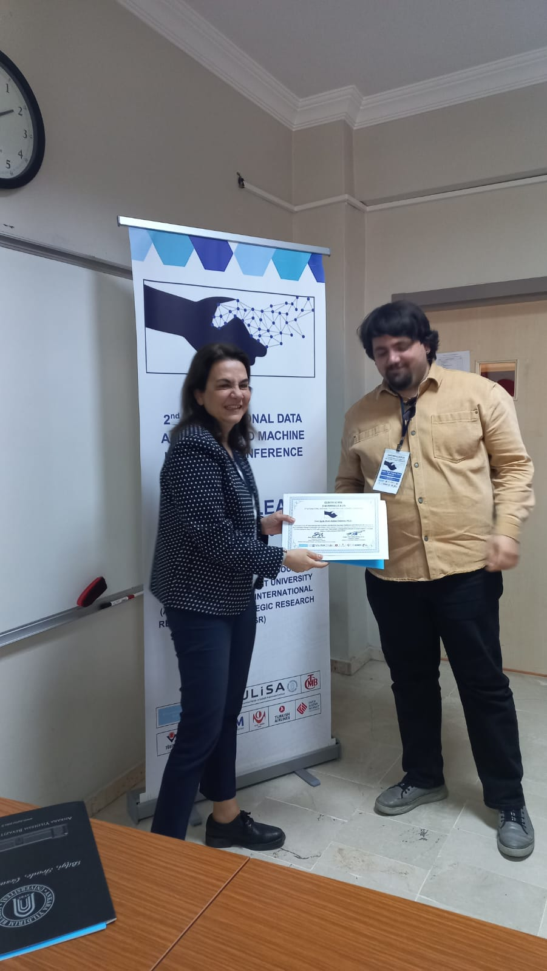
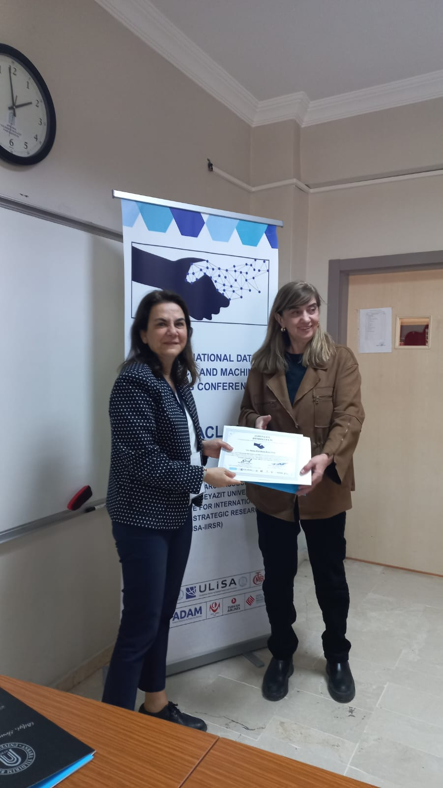
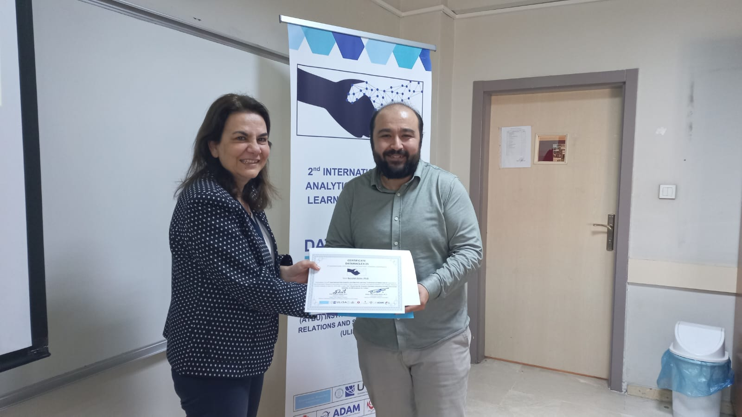

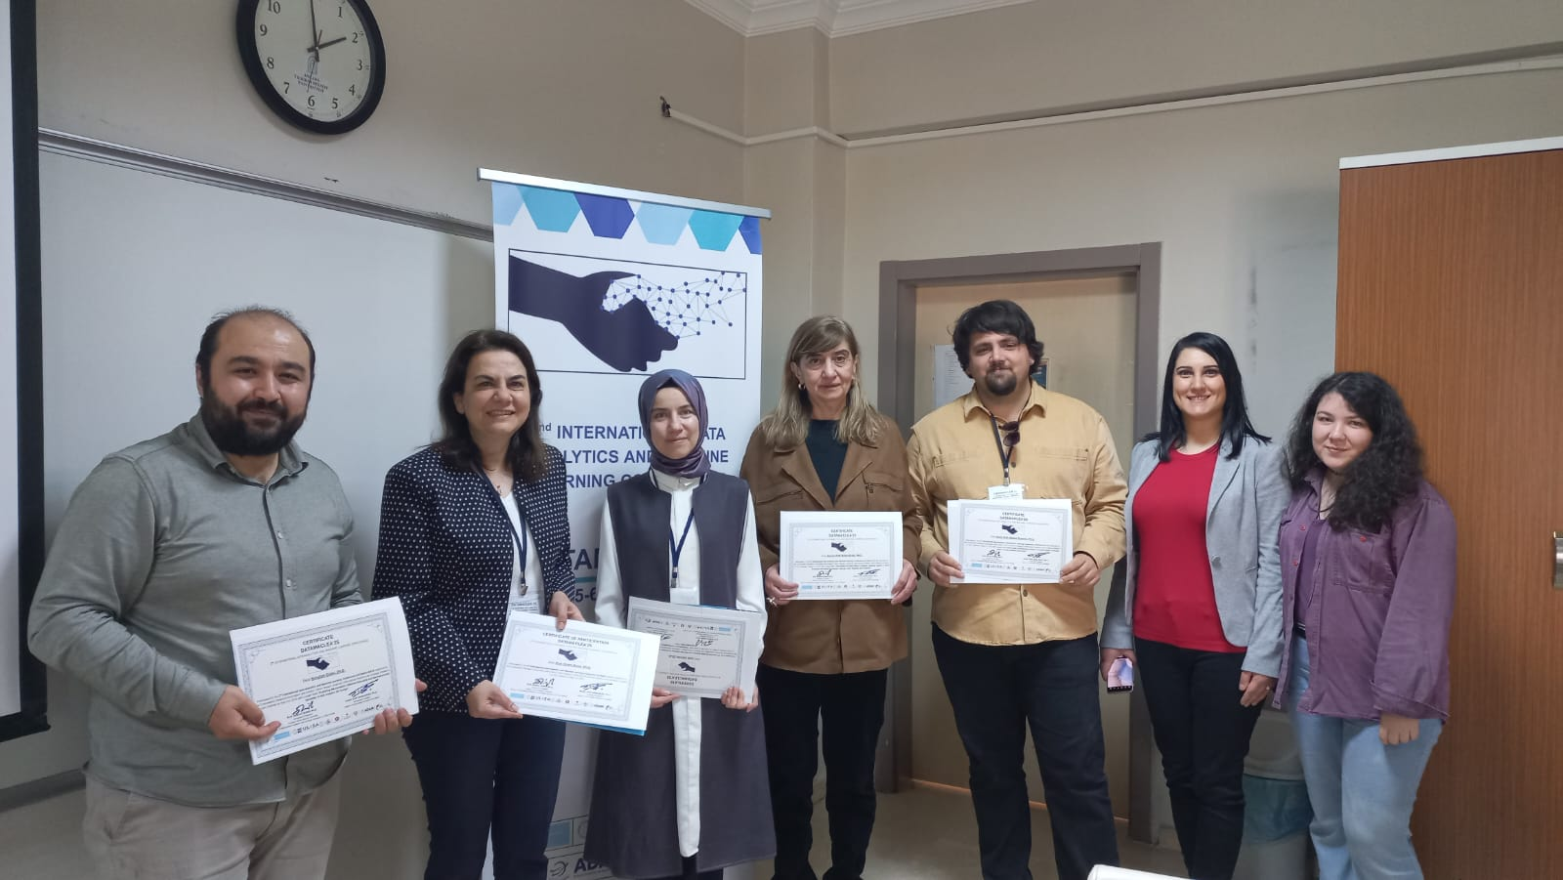

Online Sessions
Prof. Dr. Arzdar KİRACI
Siirt University, Türkiye
“A Repeated Cross-Sectional Analysis for Digital Financial Inclusion in Organization of Islamic Cooperation Countries”

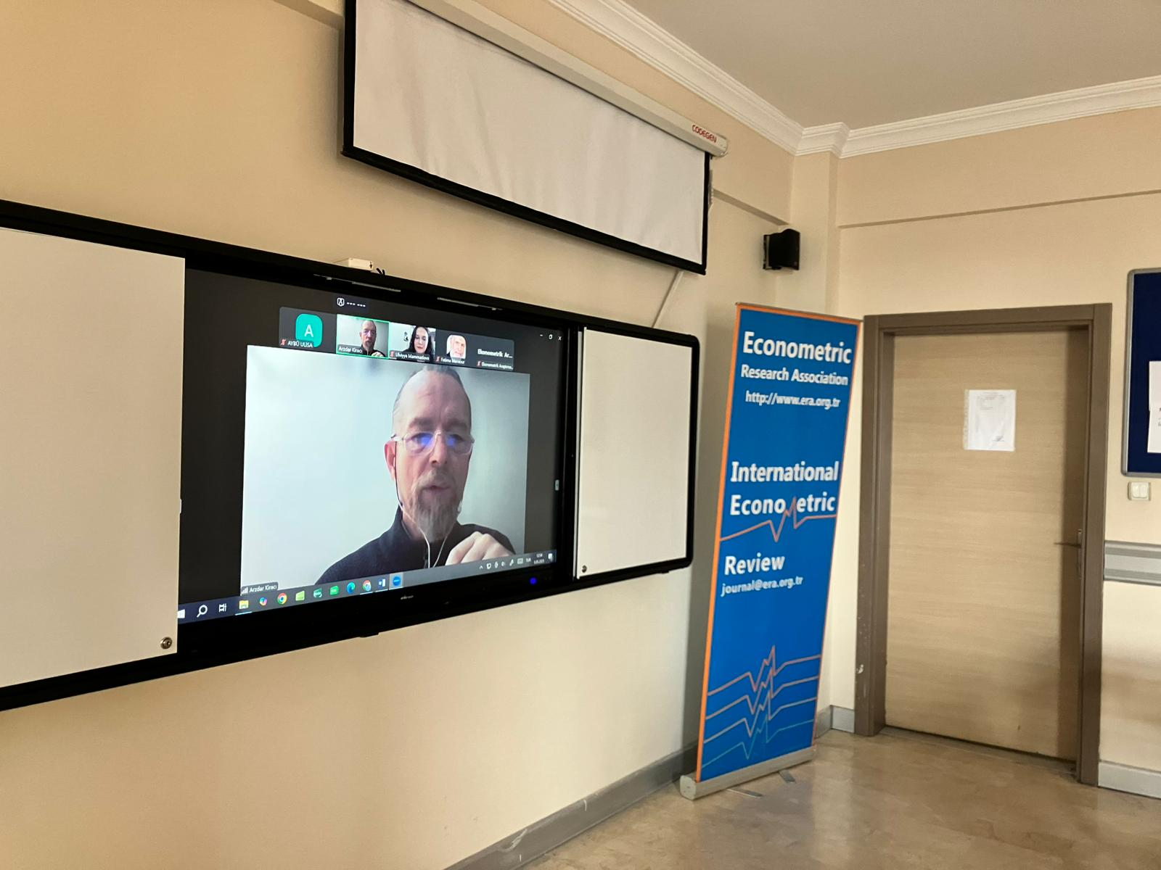

Gala Dinner


